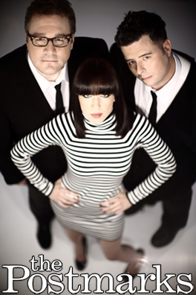

Memoirs at the End of the World
Out August 25th on Unfiltered Records

The concept for The Postmarks second record, Memoirs at the End of the World was born at a dingy bar on Manhattan's Lower East Side. They wanted to go into darker territories that the first album only hinted at. After the release of their debut in 2007, their love for cinematic themes and classic pop needed to be more than that... it needed to be realized on a grand scale in a way that still said: "The Postmarks were here," scrawled across a studio wall.

Lead singer/songwriter Tim Yehezkely, we should point out, is a gal with a boy's name; a beautiful, yet inscrutable individual possessed of a soft-textured voice that's simultaneously seductive and detached. When Tim Yehezkely sings, clocks stop, people listen, and ice cream refuses to melt.

So, how did an Anglophile/Francophile indie band come to form in the rock cover-versions hub that is South Florida? Jonathan Wilkins had been based in San Francisco scoring music for independent films while Christopher Moll – born in the Bronx – had already established himself as a gifted composer, arranger and producer around Miami, Fort Lauderdale and West Palm Beach. He also shared Wilkins' passion for film music, and as Wilkins tells it, the pair's friendship was sealed by a shared appreciation of the score for the 1973, Christopher Lee and Peter Cushing-appointed gore-fest Horror Express, a flick they'd both seen as kids.

By 2004, Wilkins was periodically DJ-ing at Dada, a Palm Beach venue that sometimes had open-mic nights. One evening a girl with a boy's name got up. It was Tim Yehezkely, of course, and when the enigmatic, Tel Aviv-born singer managed to silence, then enthrall, the normally rowdy crowd, Wilkins approached her afterward, and made sure Moll had a chance to see her. The Postmarks were soon born.

The trio recorded their beguiling debut album scored for strings, brass and woodwind, and found a home on Andy Chase's Unfiltered Records in the Spring of 2007. The band soon headlined a national tour, played shows with Múm, The Apples in Stereo, The Album Leaf and The New Pornographers, took the stage at Lollapalooza in 2007 and made a memorable appearance on Nickelodeon’s cult kid’s show Yo Gabba Gabba. A year later they embarked on a recording project that culminated in a covers album entitled By the Numbers, which the band released in November of 2008.

The Postmarks recorded Memoirs themselves between August of 2008 and February of 2009 in their home recording studios, taking a collaborative approach to the process. The resulting 13-track album combines the band's proclivity for gritty, atmospheric pop songs with enchanting melodies that draw significant inspiration from film soundtracks. Memoirs is a leap forward for The Postmarks, expressed with ambient textures from dub reggae, horn arrangements from classic soul, and elements of experimentation reminiscent of sounds heard at the birth of electronic music.

