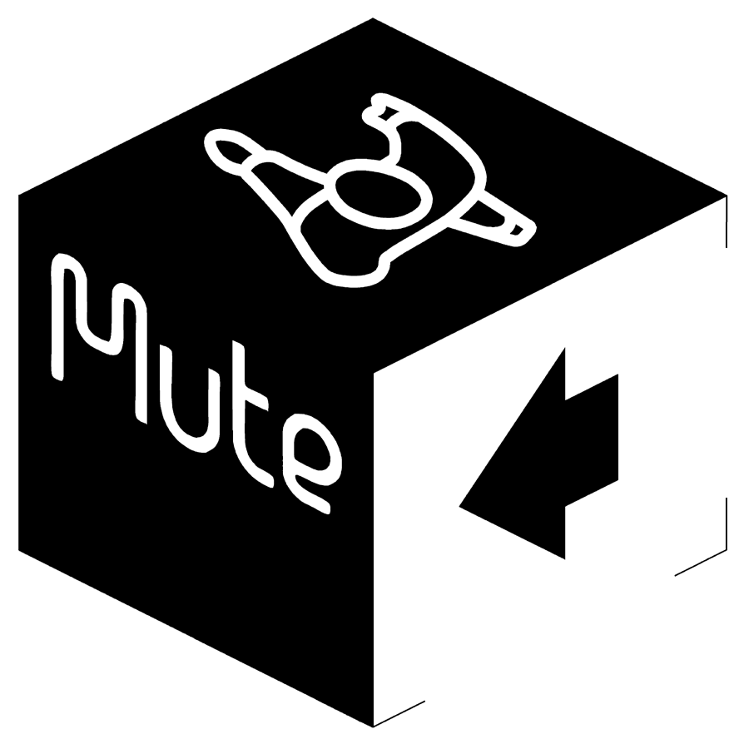

LIARS

SISTERWORLD

BRAND NEW ALBUM - 8th MARCH 2010

LIARS announce the release of their fifth studio album, Sisterworld, on 8th March 2010.

Sisterworld, the follow up to Liars (2007), was written and recorded in Los Angeles by Liars and Tom Biller (Kanye West, Beck, Where The Wild Things Are / Eternal Sunshine Of The Spotless Mind soundtracks)
This is the first Liars album to be recorded in the USA since 2004’s They Were Wrong, So We Drowned and sees Angus Andrew, Aaron Hemphill and Julian Gross taking inspiration from fringe characters lured to LA and the resulting subcultures and alternate spaces that they generate.

Sisterworld is Liars’ own space, completely devoid of influence, somewhere
remote from the false promises and discarded dreams amassed in LA. In it Liars explore the underground support systems created to deal with loss of self to society.

Say Liars, “We're interested in the alternate spaces people create in order to maintain identity in a city like LA. Environments where outcasts and loners celebrate a skewered relationship to society”.

Go to http://www.thesisterworld.com/ to enter Sisterworld.

Album tracklisting
Scissor
No Barrier Fun
Here Comes All The People
Drip
Scarecrows On A Killer Slant
I Still Can See An Outside World
Proud Evolution
Drop Dead
The Overachievers
Goodnight Everything
Too Much, Too Much

www.liarsliarsliars.com / www.myspace.com/liarsliarsliars
www.mute.com / www.thesisterworld.com

