IRMIN SCHMIDT
Filmmusik Anthology Vol. 4&5

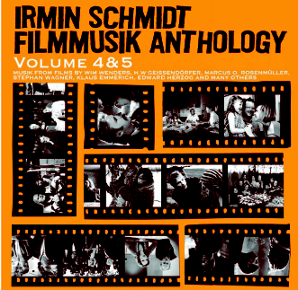

DOUBLE CD RELEASE: 5 OCTOBER 2009

Irmin Schmidt releases Filmmusik Anthology Vol 4&5 on Mute / Spoon on 5 October 2009.

Founder of the legendary German rock group CAN, Irmin Schmidt has been writing music for films for over 40 years, and as a trained pianist, composer and conductor, has roots in classical music, jazz, and of course in rock music.

This double CD release, Filmmusik Anthology Vol 4&5, follows 1994’s Anthology Soundtracks 1978 -1993 and contains a selection of Schmidt's works over the last 10 years for 20 different films for both the big screen and television. The anthology includes tracks from the critically acclaimed German TV series Bloch and Tatort and the award winning film Schneeland.

These pieces of music are a fascinating insight into the art of film score music from a veteran who has honed his craft masterfully over the years as well as being a wonderful album to just sit, relax and enjoy.
Filmmusik Anthology Vol. 4&5 also includes eight tracks from the original score of the latest Wim Wenders film, Palermo Shooting, which premiered in the Official Selection of the Cannes film festival 2008. The original film score is available digitally on Mute.

Irmin Schmidt has been commissioned by the Ludwigsburger Schlossfestspiele (Ludwigsburg Castle Festival) to present an evening of orchestrations of his work for film in summer 2010. A selection of pieces (some included on the album Filmmusik Anthology Vol 4&5) will be transcribed for orchestra and the concert will be conducted by the composer himself. This exclusive event is being organised in co-operation with the Baden-Würtemburg Film Academy. In addition Irmin Schmidt will be holding a series of workshops at the prestigious film school.

For further information please contact Zoe Miller at Mute HQ
zoe.miller@mutehq.co.uk / 020 7752 5477

http://www.irminschmidt.com

